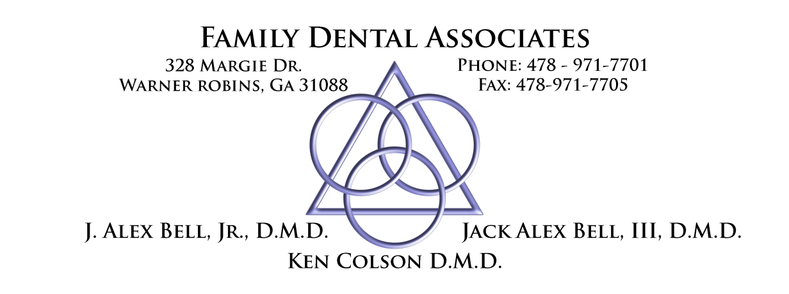

Post-Operative Instructions for Cavity Varnish

Brush and floss teeth before applying cavity varnish
Dry tooth with a Q-Tip
Apply a small amount of varnish with another Q-Tip on the advised tooth (or teeth).
Allow varnish to dry by breathing through your mouth
Do Not eat, drink, or brush for about 15 mins after applying varnish.
If you have any questions or concerns, please do not hesitate to call the office @ 971-7701

